03.03
REPORTING BACK
Process Design & AMOS Configuration Document
Purpose
This Process Design document is provided to Key-Users to record their key decisions regarding the AMOS Process design and the required AMOS configuration.
It is updated throughout the Project Definition Phase and used as the baseline for the Final Acceptance prior to Go-Live
Revision
Author, Name | Date | Notes
Business Consulting | June 2024 | Revision 0.0
Jakub Sadowski | June 2025 | Revision 1 – Visio flowchart updated

Table of Contents

1. Process Overview & Objectives 3
2. Regulatory References 3
3. Definitions & Glossary 3
4. Process Tasks 4
5. Process Dependencies 4
6. Process Flow 5
7. Process Design Questions 7
8. Data (Source) Mapping 8
9. Other Software Used 8
10. AMOS Configuration 9
a. Basic Data 9
b. Parameters 9
c. Workflows 10
d. Scheduled Tasks 11
e. API’s & Interfaces 11
11. UAT Guidance 12
12. Annex – Additional Info 12

Process Overview & Objectives

Process General Description:
This process concerns the Reporting Back action, which represents in AMOS the acknowledgment by the operator of the performance of a repetitive maintenance task or of an engineering document.
Main Process Objective (Outputs & Outcomes) :
"Repetitive Maintenance Events" subject to reporting back are:
- Single Running Task Cards
- Checks
- On-Wing Component Requirements
- Repetitive Engineering Documents
The reporting back of a repetitive maintenance event (and only its reporting back) triggers in AMOS:
- the calculation of its next due
- the creation of the historical record
- the generation of the next pending event
The reporting back of a non-repetitive engineering document (and only its reporting back) triggers in AMOS:
- the update of the document status
- the activation / de-activation of maintenance tasks which applicability is based on the modification status in reference to the engineering document
The closure of a maintenance event is an MRO function and does not have to be confused with its reporting back, which is an Operator's function part of the continuous airworthiness management and control. In fact, the closure of a maintenance event is in general a prerequisite for its reporting back. (Please note: in exceptional cases, this behaviour in AMOS can be customised via the configuration of dedicated parameters to allow the reporting back of maintenance events not yet closed by the MRO).

Regulatory References

- EASA Part M - Subpart C M.A.305 Aircraft Continuing Airworthiness Record System
- EASA Part M - Subpart C M.A.303 Airworthiness Directives
- EASA Part M - Subpart B M.A.201 Responsibilities
- EASA Part CAMO - CAMO.A.315(c) Continuing airworthiness management
- FAA Title 14 CFR § 121.363 Responsibility for Airworthiness
- FAA Title 14 CFR § 91.405 Maintenance Required
- FAA Title 14 CFR § 91.409 Inspections

Definitions & Glossary

Key-Words | Explanation
Reporting Back | Represents the acknowledgement by the operator of the performance of a repetitive maintenance task or of an engineering document.
Maintenance Item / Maintenance Event | A scheduled or unscheduled maintenance task to be performed on the aircraft
Check | A collection of tasks that can be planned as a single Maintenance Item
On-wing Component Requirement | A component maintenance task that can be performed without removing the component from the aircraft
Single Running Task Card | Free routine task that can be planned as a stand-alone item
Work Package | An object representing a Maintenance Layover in AMOS, and which contains the maintenance events to be performed during the layover itself

Process Tasks

Business Process Task / Actions / Activities:
- Report back repetitive maintenance event from the maintenance forecast, from the dedicated reporting back APN, from a work package
- Report back an engineering document from the maintenance forecast, from the dedicated reporting back APN, from a work package
- Report back a maintenance events from a work package using the layover's end date

Process Dependencies

Input
- AMOS Business Processes in area 08 – Aircraft Maintenance: Repetitive maintenance events and engineering documents that are performed and closed within the Aircraft Maintenance business processes are subject to a reporting back action
Connected
- NIL.
Output
- AMOS Business Process 03.01 – Planning and 03.02 – Work Package Generation: the generation of the next pending event for a repetitive item is triggered by its reporting back. Its due values are calculated based on the counters value at the reporting back and the resulting pending event is available for being considered during the planning process. At the same time, the maintenance item occurrence that has been reported back – with its old due values – disappears from the plannable events list. In the same way, an engineering document that is reported back disappears from the plannable events list.
- AMOS Business Process 01.04 – SB & AD Assessment and 03.04 – Modification Campaigns: The reporting back of a non-repetitive engineering document is the trigger in AMOS for the update of the document status.

Process Flow
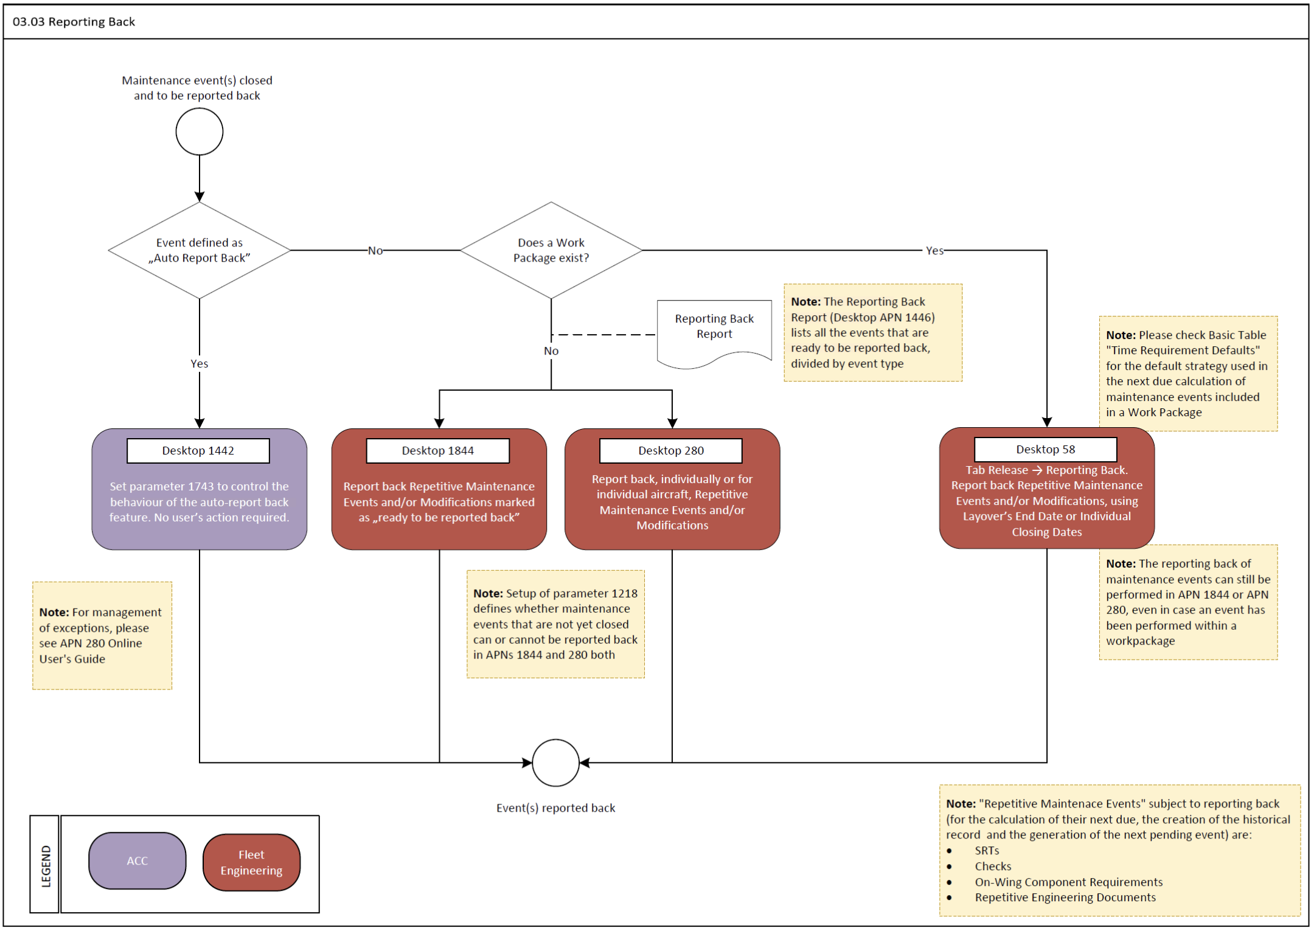

Process Flow Notes:
- There is the option in AMOS to set a maintenance event (e.g. the tasks or checks with a shorter interval) as to be "auto-reported back" at their closure, so as not to generate a time lag that would hinder the scheduling of the next pending event. There are some exceptions to the possibility of performing an auto-report back – see APN 280 Online guide for a comprehensive list of cases.
- Events to be auto-reported back are defined as such in the originating requirement (Maintenance Program Task, Engineering Document, Check, etc.).
- In general, the calculation of the next due of a repetitive event is based on the date of reporting back - and not on the closure date. With the auto-reporting back, the default reporting back date will be the closure date. In any case, different strategies for the calculation of the next due can be set in AMOS (see parameter 898).

Process Design Questions

# | Question | Answer
1 | Would the reporting back process for repetitive maintenance events be allocated under the Planning dpt. or the Technical Records dept.?
2 | Would the reporting back process for non-repetitive engineering documents (modifications) be allocated under the Planning dpt., the Engineering dept., or the Technical Records dept.?
3 | How is the reporting back process handled? Should the relevant workflows be activated to inform the responsible department of the closure of a maintenance event to be reported back, or does the process rely on the daily generation of a reporting back report, or else on the information shown in real time by the concerned AMOS APNs?
4 | Is there any category of tasks which you wish to use the auto-report back feature for?
5 | What is the strategy used for the calculation of the next due of repetitive items?

Data (Source) Mapping

Data Sources | Description | Volume / Manual / Automatic / Static / Dynamic

Other Software Used

Other Softwares | Used by: | Description

AMOS Configuration

Basic Data

Basic Data Table | Notes
Time Requirement Defaults | Defines the default Time Requirement Next Due Calculation Strategy for different kind of maintenance events
Maintenance Event Extension Codes | Contains the codes to be used in the reporting back for filling in the interval usage reason code, i.e., in case an interval has been overdrawn (extension) or cut short (reduction)

Parameters

Parameter Code | Parameter Name | Notes
1218 | REPORT BACK MAINTENANCE EVENT ALTHOUGH WO IS NOT CLOSED | By setting the value of the Amount [String] to "Y" the application Reporting Back Maintenance Event allows to report back a Maintenance Event although the corresponding WO is not closed.  By setting the value of the Amount [Integer] to 1 the application Reporting Back will disable the closed fields in case the Reporting Back is performed only for one Aircraft Document Maintenance Event and with a closed workorder at a time.  By setting the value of the Amount [Float] to "1.0" the application Reporting Back Maintenance Event prevent to report back a Maintenance Event Task card if the Task card is not closed. | Int=0, Float=1.00, String=N
1743 | Enable Auto-Report Back | The String value of this parameter gives the possibility to automatically set the auto-report back checkbox to True in Time Requirement definition of ad-hoc job instruction cards.  The Int value triggers auto-report back when the work package Certificate Release to Service (CRS) is issued. This option is valid for all maintenance events in a work package. | Int=0, String=Y
1888 | Report back overdue events in Workpack Context | This parameter controls the Interval Usage Reason Code mandatory / non-mandatory behaviour during reporting back of events that become overdue during the maintenance ground time (during the work package).  If the maintenance event is due before the ACTUAL start date of the work package or not assigned into a work package the Interval Usage Reason Code is always mandatory | String=N
1951 | Skip the validation of installed / not installed for the PN change during reporting back | When setting this parameter to Y, the part number change will be enabled when reporting back documents for serviceable components that are not installed. If a component is unserviceable the part number will remain the same and must be changed during goods receiving / component inspection. | String=N

Workflows

Workflow Number | Workflow Name | Notes
82 | Reporting Back Taskcard
84 | Reporting Back Modifications
85 | Reporting Back Check
93 | Maintenance Event Extension
305 | Maintenance Event Transfer
306 | Reporting Back Part Requirements
399 | Undo Reporting Back Check
400 | Undo Reporting Back Taskcard
401 | Undo Reporting Back Modifications
402 | Undo Reporting Back Part Requirements
628 | Document Auto Report Back Inconsistency

Scheduled Tasks

Scheduled Task Reference | Frequency | Notes
NIL

API’s & Interfaces

Reference | Direction | Trigger | Frequency
NIL

UAT Guidance

Annex – Additional Info

